Gaussian Mixture Models — GMM

Definition
A Gaussian Mixture Model (GMM) is a probabilistic model that assumes the observed data is generated from a mixture of several Gaussian probability distributions.
Instead of saying:
"This point definitely belongs to Cluster 1."
GMM says:
"This point has a 75% probability of belonging to Cluster 1 and a 25% probability of belonging to Cluster 2."
Therefore, GMM provides soft/probabilistic cluster assignments.

GMM Intuition
Suppose we have customer data.
There may be three underlying customer groups:
Cluster 1
● ●
● ● ● ●

Cluster 2
● ● ●
● ● ● ●

Cluster 3
● ● ●
● ● ● ●
GMM assumes that each group can be represented by a Gaussian distribution.
So:
P(X) = Gaussian1 + Gaussian2 + Gaussian3
More precisely, it is a weighted mixture.

Gaussian Distribution
A one-dimensional Gaussian distribution is:
p(x) = $\frac{1}{\sqrt{2πσ}2}e$xp(−$\frac{(x-μ)2}{2σ2}$)
where:
- μ = mean
- σ² = variance
For multiple dimensions:
N(x∣μ,Σ) = $\frac{1}{(2π)d/2∣Σ∣1/2}$exp[−$\frac{1}{2}$ (x−μ)^{T}Σ⁻¹(x−μ)]
where:
- d = number of features
- μ = mean vector
- Σ = covariance matrix

GMM Mathematical Formulation
Suppose there are KK Gaussian components.
The mixture distribution is:
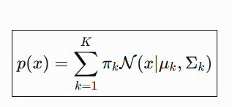
where:
π_{k} ≥ 0
and:
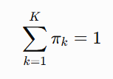
Here:
- π_{k} = mixture weight
- μ_{k} = mean of Gaussian k
- Σ_{k} = covariance of Gaussian k

What Is a Mixture Weight?
Suppose: K=3
and:
π1 = 0.2, π2=0.5, π3=0.3
Then the model estimates that approximately:
- 20% of the population comes from component 1
- 50% from component 2
- 30% from component 3

Latent Variable in GMM
GMM assumes an unobserved variable:
z_{i}
representing the component responsible for generating observation x_{i}
For example:
z = 0 → Gaussian 1
z = 1 → Gaussian 2
z = 2 → Gaussian 3
But zz is not directly observed.
Therefore, it is called a:
Latent Variable​

Posterior Probability / Responsibility
The probability that observation xix_i belongs to Gaussian k is:
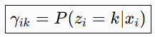
Using Bayes' theorem:
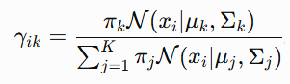
This is called the responsibility of component k for observation i.

GMM Geometric Intuition
K-Means effectively creates regions based on distances to centroids.
GMM instead creates elliptical probability contours.
For example:
Gaussian 1

______
.-' '-.
.' '.
/ \
\ /
'. .'
'-.______.-'
The covariance matrix controls:
- Shape
- Orientation
- Spread
of the Gaussian.

Covariance and Cluster Shape
This is one of the biggest differences between GMM and K-Means.
A covariance matrix can produce:

Circular cluster
****
** **
** **
** **
****

Elliptical cluster
**********
*** ***
*** ***
*** ***
**********

Rotated elliptical cluster
****
****
****
****
Thus GMM can model clusters that are not spherical.

GMM and Maximum Likelihood
The parameters of GMM are commonly estimated by maximizing the likelihood:
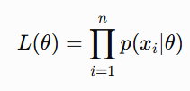
where:
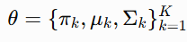
Usually we maximize the log-likelihood:
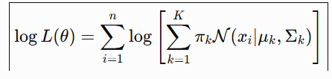
Direct optimization is difficult because of the summation inside the logarithm.
This leads to the Expectation-Maximization algorithm.

Expectation-Maximization — EM
GMM is commonly fitted using:
Expectation-Maximization
EM alternates between two steps:
Initialize parameters
↓
Expectation Step
↓
Estimate responsibilities
↓
Maximization Step
↓
Update parameters
↓
Repeat

E-Step
Calculate:
That means:
Given the current Gaussian parameters, how strongly does each Gaussian explain each observation?

M-Step
Update parameters using the responsibilities.
Effective number of observations assigned to component k:
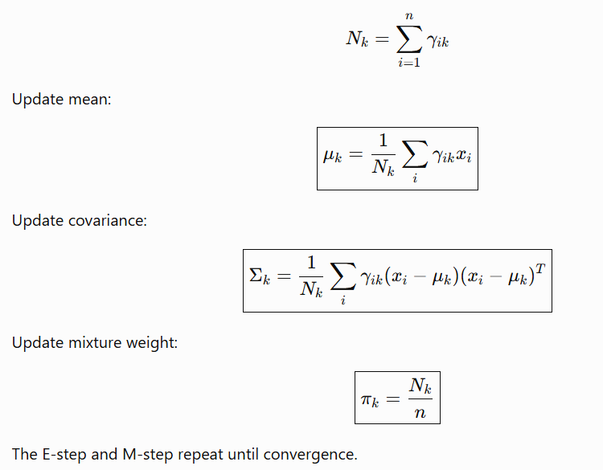

Hard vs Soft GMM Assignment
labels = gmm.predict(X)
gives:
0, 1, 2
This is a hard assignment.
But:
gmm.predict_proba(X)
might produce:
Cluster 0 Cluster 1 Cluster 2

0.90 0.08 0.02
0.10 0.85 0.05
0.20 0.30 0.50
This is a soft assignment.

GMM Covariance Types
Scikit-learn provides:
full
tied
diag
spherical

Full
Each component has its own full covariance matrix.
Most flexible.

Tied
All components share one covariance matrix.

Diagonal
Each covariance matrix is diagonal.
Features are not modeled with cross-covariance.

Spherical
Each component has a single variance.
Least flexible.

Choosing Number of GMM Components

AIC
AIC balances:
- Model fit
- Model complexity
AIC = 2p − 2log L
where:
- p = number of estimated parameters
- L = maximum likelihood
Lower AIC is generally preferred.

22. BIC
BIC = p log(n) − 2log L
BIC penalizes model complexity more strongly than AIC when nn is sufficiently large.
Lower BIC is generally preferred.

When Should You Use GMM?
Choose GMM when:
- You expect Gaussian-like clusters.
- Clusters may be elliptical.
- You need probability estimates.
- You want soft cluster assignments.
- You want a generative probabilistic model.
- You want to compare models using AIC/BIC.
Example applications:
- Customer segmentation
- Image segmentation
- Speaker recognition
- Financial modeling
- Density estimation

